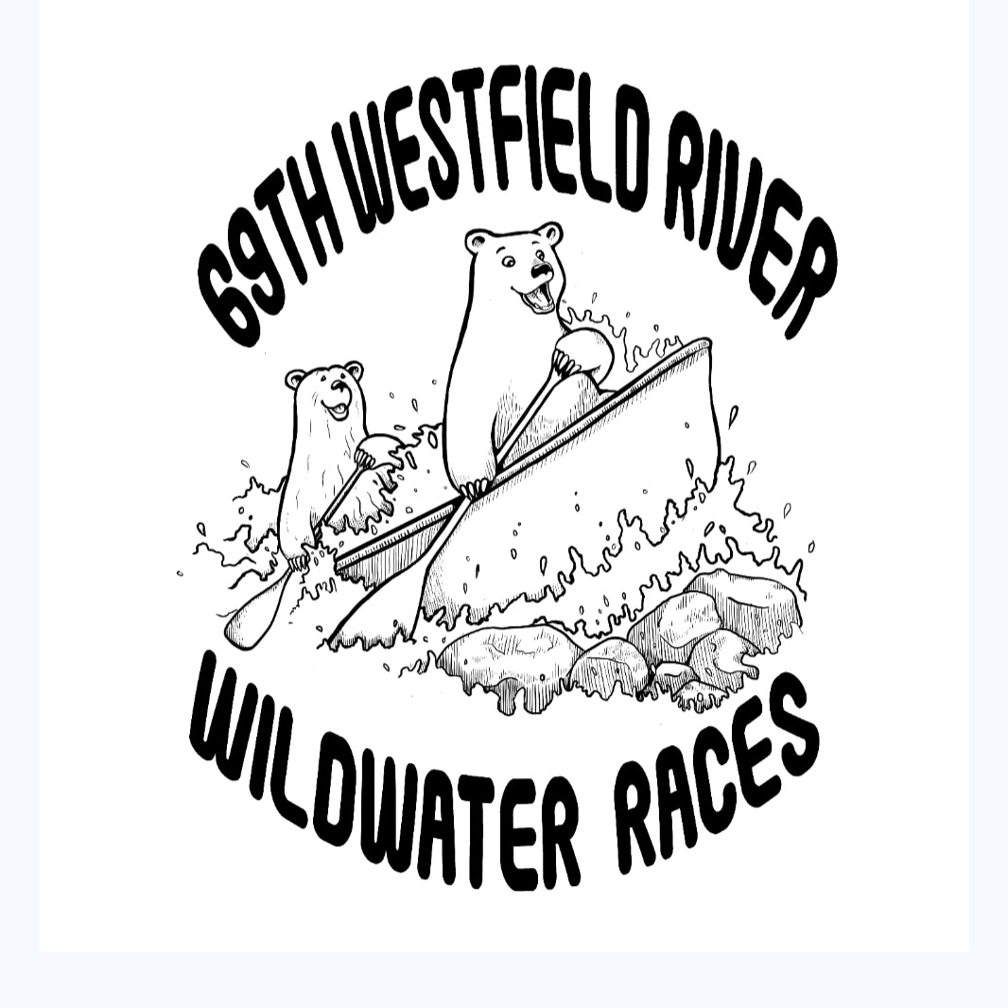
Welcome to the 69th paddling of the Westfield River Wildwater Races!
Saturday, April 20, 2024

Expert Races (advanced/expert paddlers only)
Knightville Dam, off Rt. 112 in Huntington
8:30AM Boat Inspections Start
9:00AM Racer Meeting
9:30AM Start (30 second intervals)

Classic Races (intermediate/advanced/expert paddlers)
Huntington, off the Rte 112 green bridge in the Mass DOT lot 10:00AM Boat Inspections Start (ongoing as racers arrive)
10:30AM Racer Meeting (ongoing as racers arrive)
11:00AM Start (30 second intervals)

Registration and Place Allotment
- All registration is online this year at westfieldriver.org/races.
- The Early Bird registration fee is $35 for the Expert and Classic (up until 3/30 at 11:59PM). Registration April 1 - April 14 11:59 PM is $45. Registration 4/15-17 is $75. Please register early. You will save money and it helps make check in for everyone seamless.
- Racing as a team? Each person needs to register and each needs to sign a waiver. You will designate your team/partner in the system with your last names as a team name (smith/jones).
- For those wishing to do both races (the Meister), there is a $20 additional fee. Meister teams must be the same two paddlers for both races.
- All registrations include a $5 insurance fee and those registered must sign the insurance waiver on the registration site.
- Registration closes April 17th at 11:59PM.
- There will be a randomized draw on Thursday the 18th to determine start order for all races. You will be emailed your start time by Friday 4/19 at 3PM.
- Racers will start at 30 second intervals.
- If you miss your assigned start time you must wait until the start official allows you to enter the water. This could be soon after you arrive at the start line or it may be after all other racers have started. Racers who miss their start will not be allowed to interfere with other racer's timely, safe, scheduled starts. Please note that your original start time is when your personal timing starts.
- All Meisters will start the Classic race after all Classic classes have been started to allow time to rest and to coordinate shuttles.

Race Bibs
- Race bib pickups for the Classic will be at the Classic start in downtown Huntington 8AM - 11AM. Expert racer bibs will be available at the Knightville Dam starting at 8AM.
- The race bibs are single use. There is no need to turn them in at the end of the race – keep them as a souvenir, just don’t litter. Each tandem boat will have two numbers. Each paddler must wear a bib attached to the front of their PFD. Solo paddlers and kayakers must attach their numbers to both the front and back of their PFD.

FREE Shuttle for Paddlers – 10 AM - 3PM

A free shuttle bus will make loops of the course to help paddlers return to their cars and simplify parking. The bus will originate from the race finish at Woronoco Dam at 10AM. It will make stops at the Classic start in downtown Huntington, the Rte 20 pull off across from the Hilltown Community Health Center (parking available), Strathmore Park (parking available) and the race finish near Woronoco Dam. Note to both paddlers and your spectators: please follow all NO parking signs on Rte 20. You will get ticketed unless you are parked in a designated spot. This is a safety protocol.

Rules
- You must race at your designated start time.
- We cannot accommodate racing with friends.
- Important information will be announced at pre race meetings at Knightville and the Classic start area. Attendance is strongly encouraged. The pre-race meetings will start at 9:00AM at Knightville and 10:30AM at the Classic Start. Race meetings for the Classic Race will be ongoing as paddlers arrive for their assigned starts.
- No alcohol will be allowed in and around the start area of both races. In the interest of safety we ask that all paddlers and spectators refrain from the use of alcohol before the races.

Safety
- The Westfield River Classic Race contains class two rapids and has several challenging sections including the Hill & Dale Rapid. The Expert Race has a much higher level of paddling difficulty with some class 3 rapids. The Expert Race is for experienced whitewater paddlers only.
- If you have never paddled whitewater before, you should not attempt either race unless you are an experienced flat water paddler with the correct whitewater boats and equipment as well as the proper clothing/wetsuit/drysuit to protect you against cold water immersion. You should plan to attend one of our two clinics for instruction on how to paddle rapids.
- If you are new to whitewater we STRONGLY suggest attending one of the two race clinics and learning from experts on what to expect on the course. We have had class winners who attended both clinics and increased their skills immeasurably.
- Every paddler is required to wear a Coast Guard-approved or ISO certified, over-the-shoulder life jacket.
- Helmets are mandatory for all kayakers and recommended for all other boats.
- Grab loops or 8’ tie down ropes at bow and stern are recommended.
- We strongly recommend that all open boats have flotation devices attached. This can be in the form of professional canoe/kayak air bags, truck inner tubes or styrofoam blocks secured inside the boat. This will absolutely help you and others self rescue your boat if you go over.
- It is every paddlers responsibility to look out for other paddlers needing help or rescue. See someone in distress? Give aid to those in need.

Awards and Race Celebration
- Strathmore Park off of Rte. 20 is the post-race venue.
- Awards will be distributed at approximately 3:00 PM.
- Strathmore Park has a large pavilion and restroom facilities.
- Racers, family, and friends are all welcome.
- There will be three food trucks (North Elm Butcher Block, Ginger Love and Broken Wolf), Blue Farm Bakery desserts, a live band (The 413s) and a DJ plus face painting for kids.
- Please bring a garbage bag with you and be sure to take your trash out. We want to leave all areas of the race as pristine as we found them.

A Note on Assumed Personal Risk
Paddling whitewater in early spring conditions with cold water and chilly air temperatures is an inherently risky undertaking that assumes personal responsibility and acceptance for all risks encountered while paddling rapids.

You should think carefully about your decision to register for this race if you have never paddled whitewater before. It is important to realize that despite all of the safety measures the race organizers have in place, they cannot guarantee your total safety from injury or worse once you set off on the water on your own. This is not a controlled environment where your safety is guaranteed.

Race officials apply to the Army Corp of Engineers for a specific water release from the dam but river conditions are always changing that are out of the race officials' control with varying water levels, unknown and hidden obstructions such as rocks and logs, and changing severity of rapids.

Outdoor high adventure outings such as paddling whitewater rapids require physical conditioning, experience, knowledge, former instruction, proper protective clothing and footwear to guard against cold water/air exposure. Canoe and kayaks are recommended to be outfitted with air bags/flotation devices. Kayakers are required to wear approved whitewater helmets. Canoeists should carry spare paddles, bailers, and have 8’ painters on each end of the canoe and grab loops on kayaks. You must be comfortable with self rescue of yourself, your partner and your boat if you capsize as there probably won’t be anyone around to render assistance if you need help.

If you are questioning your ability to safely navigate this river because of any of the previously mentioned points, you should not register for this race. This event is not for first time beginner paddlers. Please read the article on hypothermia that is attached to the race website.

Cooperation and Assistance
Everyone’s cooperation will be needed to make sure the races and the celebration runs as smoothly as possible. Let’s make sure everyone has a good time and that the race continues its illustrious history. Please remember that it is your responsibility as a paddler to render assistance to other boaters who are in need of help or rescue on the river as you approach them.

Please send questions to wrwraces@gmail.com.
Pre-Registration opens March 1: westfieldriver.org/races
For race updates, like us on Facebook or follow us on Instagram

